AI Powered Virtual Stress Management Assistant for IT Professionals : Depresio

Shan Joel Dharmagunarathne  
Faculty of Computing  
Sri Lanka Institute of Information TechnologyMalabe, Sri Lanka  
shan.joeld@gmail.com

Chamod Ranasgala  
Faculty of Computing  
Sri Lanka Institute of Information TechnologyMalabe, Sri Lanka  
chamod.ranasgala@gmail.comDulanjaya Premarathne  
Faculty of Computing  
Sri Lanka Institute of Information TechnologyMalabe, Sri Lanka  
dulanjaya.premarathne@gmail.com

Thusithanjana Thilakarathne  
Faculty of Computing  
Sri Lanka Institute of Information TechnologyMalabe, Sri Lanka  
thusithanjana.t@sliit.lkDulaksha Harishchandra  
Faculty of Computing  
Sri Lanka Institute of Information TechnologyMalabe, Sri Lanka  
dulakshakavi@gmail.com

Buddika Harshanath  
Faculty of Computing  
Sri Lanka Institute of Information TechnologyMalabe, Sri Lanka  
harshanath.s@sliit.lk

*Abstract*—Maintaining a healthy work-life balance is essential for IT professionals' wellbeing and mental health in the intense and demanding work environment in IT industry. This research paper introduces "Depresio," an online tool for helping IT professionals create and keep a healthy work-life balance. Depresio includes a number of components that are suited to the user's mood and demands, such as music therapy, task management optimization, and a chatbot for counseling support. Depresio offers individualized recommendations and interventions to improve emotional well-being and productivity by utilizing machine learning approaches including Natural Language Processing (NLP) and ML algorithms. Additionally, a browser plugin monitors surfing behavior, allowing for proactive user involvement and real-time monitoring. The architecture, algorithms, and user-centric design of Depresio are described in this paper, along with examples of how they could improve IT professionals' mental health and overall work-life balance. Depresio seeks to promote a better and more rewarding professional life for IT workers in the contemporary workplace by empowering individuals with individualized support and solutions.

Keywords— emotion detection, music therapy, natural language processing, depression

# Introduction

Because of the challenging and quick-paced nature of the IT sector, professionals are frequently subjected to extreme pressure, which can cause stress, burnout, and an unbalanced lifestyle. This research paper introduces Depresio, an advanced web tool made to assist IT professionals in pursuing a better and more balanced lifestyle in response to these difficulties. Three essential elements make up Depresio: music therapy, a chatbot, and task management optimization. The system's combination of these elements seeks to improve IT professionals' mental health, productivity, and general quality of life. The design, functionality, and potential effects of Depresio in treating the mental health issues common in the IT industry are thoroughly explored in this research. The IT sector is widely known for its high-pressure workplace, which frequently has a negative impact on employees' well-being and work-life balance. Stress, exhaustion, and a feeling of suffocating stress and anxiety can result from the endless demands, short deadlines, and long hours. This research introduces Depresio, a comprehensive web application that makes use of the latest technologies to offer individualized support and interventions, in response to the critical need to assist IT professionals on their mental health journey. Three interconnected features make up Depresio, a chatbot, music therapy, and task management optimization. The chatbot functions as a virtual counselor, giving customers individualized guidance and encouragement when they're feeling down or overwhelmed. The chatbot engages in meaningful conversations, offering advice and empathy during trying times by utilizing the complex capabilities of chatGPT and a dataset enhanced with expertise from professional counselors and prior user encounters. Depresio uses natural language processing (NLP) methods to analyze user moods based on their social media activity, notably their tweets, in order to further improve the user experience and emotional wellbeing. The technology may personalize the music therapy component by tailoring the emotional signals and sentiment that are extracted to provide insightful information about their mental health. Using the user's mood as a guide, this tool creates playlists that are calming which serve according to the mental state of the user. In order to help individuals to relax and regulate their emotions during times of emotional discomfort, machine learning algorithms classify songs into several emotional groups and dynamically alter the music selection to match the user's mood. Additionally, Depresio provides customers with a thorough user interface to efficiently manage their tasks, maximizing task management and efficiency. The system intelligently plans and organizes jobs throughout the week by taking task information, deadlines, and typical completion times into account. This increases efficiency and lessens burdensome responsibilities. To promote rest and keep a positive work rhythm, the application also includes occasional breaks.

Depresio offers a browser plugin that monitors the user's YouTube and online browsing habits in order to facilitate active involvement and real-time help. This enables the system to recognize situations in which the user might gain from speaking with the chatbot, assisting with detecting their mood and offering immediate help. In conclusion, Depresio offers a comprehensive strategy for dealing with the issues with mental health that IT professionals have to cope with. This web application seeks to improve emotional well-being, productivity, and overall quality of life through the integration of chatbot counseling, music therapy, and task management optimization. Depresio is a useful tool for enhancing mental health in the IT sector since it uses machine learning techniques and individualized interventions. The design, functionality, and potential effects of Depresio will be examined in depth in this research report. It will also offer ideas for future upgrades.

# LITERATURE SURVEY

Paper 1 - The rise of chatbot-based systems that can monitor people's moods and emotions through their text-based interactions is now possible because of the growth of natural language processing (NLP) technology. The article Mood Detection and Counseling Using NLP and Chatbot focuses on the investigation of such systems, particularly the application of NLP methods to the identification and evaluation of people's moods for the aim of customized guidance and assistance. These systems seek to accurately categorize and react to various emotional states by utilizing extensive datasets and utilizing machine learning methods. With a focus on the research methodology, results, and prospective applications of chatbot-based systems for mood analysis and emotional support, this survey desires to give an overview of the present level of knowledge in this area.

paper 2 - Music Therapy for Emotional Regulation, Music, is long recognized as an effective means of expressing feelings and enhancing well-being. The purpose of this study is to find out how effectively music therapy works in boosting emotional control and improving general well-being. The study specifically explores how various musical genres and styles affect people's emotions and moods. The research suggests a system that may classify music according to its emotional properties by applying the capabilities of machine learning algorithms. The system can utilize this classification to create customized playlists for users that are designed to improve their emotional well-being. This study is designed to add to the expanding body of knowledge on the therapeutic potential of music and its use in enhancing emotional well-being by examining the relationship between music and emotions.

Paper 3 - Optimal Task Management for Work-Life Balance, the purpose of this project is to establish a task management system that best schedules and arranges duties for people to maintain a good work-life balance. The system makes use of machine learning algorithms to produce effective task schedules by considering elements like task deadlines, typical completion times, and individual preferences. To promote the highest efficiency and well-being, the method also includes rest and break times.

Paper 4 - Personalized Content Recommendation for Mood Enhancement, In this study, personalized content recommendations are made using machine learning algorithms that take into consideration the user's mood. The system makes suggestions for content like YouTube videos, movies, and inspirational quotes by examining individual tastes, browsing history, and identifying emotional states in order to enhance and improve the user's mood.

In summary, the above-considered literature highlights the importance of the Depresio system's machine learning techniques integration by focusing on it. The system seeks to provide IT professionals with an integrated plan for establishing and maintaining work-life balance while attending to their emotional well-being by combining natural language processing (NLP), music therapy, task management optimization, and personalized content recommendation. By advancing our knowledge and making it easier to apply intelligent systems that actively support people in achieving a better and more fulfilling work life, this research offers significant contributions to the area. The Depresio system aims to empower IT, employees, through this integration by giving them the knowledge and skills they need to navigate their professional paths with improved emotional resilience and overall mental health.

# EXISTING SYSTEM

Existing System: To offer assistance and direction to people in need, the present counseling platforms frequently rely on human therapists. These platforms have several drawbacks even though they have a useful purpose. Access to support may be delayed due to a lack of human counselors, particularly during busy times or in emergency situations.

Additionally, the level of individualized care provided by human counselors may differ, and the expense of such services may be a barrier for some people. Additionally, the current remedies frequently lack interaction with additional functions like task management and music therapy, which are crucial parts of a comprehensive strategy for work-life balance. Existing programs in the world which address work-life balance and mental health in the field of IT professionals have a number of drawbacks. First of all, there are frequently a lack of human counselors, which might cause delays when clients need assistance right away. The absence of 24-hour availability makes it difficult to provide immediate assistance and may make people feel more stressed out. Second, the knowledge, specialization, and availability of human counselors can have significant effects on the overall quality of counseling experiences. Support that isn't reliable enough can make counseling less successful and make it more difficult for people who want to improve their well-being. Additionally, the expense of professional counseling services can be burdensome for people with little financial resources, making them a considerable barrier to acquiring them. Due to this obstacle, many people are unable to access the support they might want. Last but not least, current systems frequently ignore the introduction of other crucial components like music therapy and task management and focus instead only on counseling. The absence of these essential elements restricts the wide range of work-life balance solutions since they do not take into consideration the broader needs of people pursuing emotional well-being. Overall, these drawbacks highlight the need for novel strategies that can get over these barriers and offer more inclusive, reachable, and integrated solutions.

# Proposed system

Our research proposes Depresio, an integrated approach aimed at improving work-life balance and emotional well-being among IT professionals while overcoming the drawbacks of current methods. First of all, Depresio guarantees constant accessibility, enabling customers to get support and direction whenever they need it without being reliant on counselor availability. This deals with the issue of limited accessibility in urgent situations. Second, by utilizing ChatGPT AI technology, our system offers trustworthy and personalized help. The chatbot can adjust to individual needs and constantly provide helpful and empathetic advice by drawing on a vast repository of counseling specializations. This reduces the inconsistent counseling interactions encountered in typical approaches. Thirdly, through the elimination of the price barrier related to hiring an experienced therapist, Depresio provides an affordable choice. This makes it easier for people with low incomes to obtain services. Our solution also adopts an integrated approach through including task management and music therapy functions. It offers mood-based customized music playlists and uses work optimization algorithms to concurrently encourage emotional health and productivity. the least, Depresio uses real-time monitoring and intervention through a browser plugin, enabling proactive involvement when users need help or exhibit signs of discomfort while using the internet or watching YouTube. Depresio offers a complete, approachable, and user-centered solution that deals with the drawbacks of current systems and aids IT professionals in achieving work-life balance and emotional well-being.

# SYSTEM ARCHITECTURE

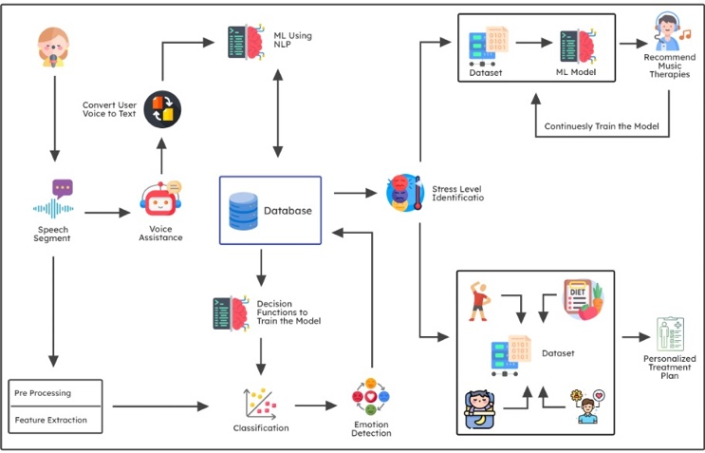

# MODULES

User Our system's User Interface Module consists of up of three essential parts. First off, the Chatbot Interface gives individuals a simple way to communicate with the AI-powered chatbot. Through this interface, people may converse, ask for advice, and express their worries while getting customized support targeted to their needs. Second, the Music Player Interface shows the system's music player and provides options so that users can listen to custom playlists. This interface facilitates relaxation, mood enhancement, and emotional well-being by using music therapy. The Task Management Interface, which also enables effective task management and supports a routine that balances work and life, provides users with an intuitive platform to manage their daily tasks and monitor schedules.

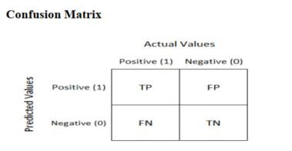

Our system's Natural Language Processing (NLP) module plays an important role for effectively identifying and responding to user interactions. The module analyzes user input using text analysis to find emotions, worries, and conversational topics. This analysis gives the system a better knowledge of the user's requirements and lays the basis for individualized support. Another element that establishes the emotional component or emotion conveyed in the user's communications is sentiment analysis. The system can accurately determine how the user feels by determining the feeling, enabling empathetic and customized answers. Additionally, the system can recognize the user's requests or intentions from their communications because of intent recognition. The system can respond accurately and take consideration of the user's unique needs thanks to this recognition.

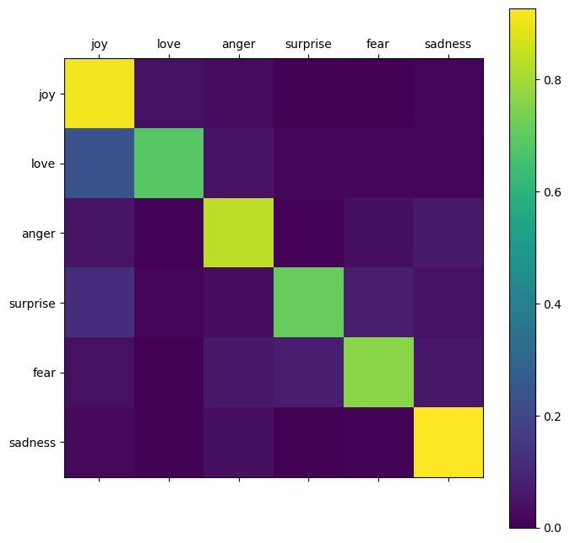

Music Therapy module includes a variety of features to improve mental health through music. The module conducts Mood Classification, classifying music into various moods using machine learning methods. With the help of this classification, the algorithm is able to figure out the songs' emotional properties and make music recommendations accordingly. On a foundation of the user's determined mood or emotional state, the Playlist Generation tool then generates personalized playlists. The system finds tunes that can encourage relaxation, motivation, or other desired emotional states by taking into account the user's mental needs. Users will have a stimulating and seamless music therapy experience thanks to the Music Player Integration, which easily controls music playback within the application itself.

The Task Management module's enhancement of task management and scheduling for greater work-life balance is its main objective. Users are able to enter their tasks, due dates, and expected completion deadlines into the system using the Task Input function. This improves the application's ability to log tasks and organize them. The module then applies Optimization Algorithms, which optimize task schedules based on considerations including deadlines, workload, and user preferences, using machine learning or optimization techniques. The technology can help users effectively control their duties and establish a routine that balances work and personal life by automating the scheduling process. The plan Visualization component gives the user a clear and user-friendly view of the optimal task plan. The plan Visualization component gives the user a simple and user-friendly view of the most effective task plan. This visual illustration aids user understanding and management of their calendars, ensuring that time and resources are allocated properly and ultimately promoting a more balanced and productive work life.

A browser extension that monitors user browsing activity and gathers information on websites visited and YouTube usage is a component of the User Activity Tracking module. Utilizing surfing habits and content consumption to assess the user's current mood or emotional state, this data serves as the basis for "Mood Inference." Based on this inference, the system can suggest appropriate information that meets the user's emotional needs, such as YouTube videos or inspirational quotes.

The database management module is comprised up with different parts. User profiles maintain user details, preferences, and historical information to enable customized interactions. For the objective of designing custom playlists, the Music Database provides a database of music organized by mood. For effective task management, Task Data keep details about user tasks, due dates, and completed tasks. The user interactions with the chatbot and therapy sessions are recorded in the counseling session logs for analysis and future usage.

These modules' incorporation within the Depresio system combines task management, counseling, and music therapy capabilities. The solution enhances user experience and promotes work-life balance for IT workers by utilizing NLP, machine learning, and user activity tracking strategies. It offers customized assistance, makes appropriate recommendations, and effectively manages user data to ensure a thorough and user-centric approach to enhancing mental health and work-life balance.

# CONCLUSION

In conclusion, the Depresio system provides an important breakthrough in resolving the issues that IT workers have with work-life balance. The system provides a comprehensive software solution that encourages emotional well-being and boosts productivity by integrating numerous modules and utilizing the latest innovations like NLP, machine learning, and user activity tracking. Automated stress detection with the use of machine learning as well as image processing algorithms enables secure and accurate stress assessment, offering helpful information for targeted support and interventions. The system stands out for its unique comprehensive approach, which combines counseling, music therapy, and task management performs to meet the specific requirements of each individual. A comprehensive approach that improves work-life balance and general well-being features personalized music playlists, task management that is optimized, and proactive content recommendations. The Depresio system, which significantly contributes to the field of AI for supporting emotional well-being at work, supplies IT professionals with a valuable tool for having happier and more practical professional lives with less stress and burden.

# REFFERENCES

1. G. Eason, B. Noble, and I. N. Sneddon, “On certain integrals of Lipschitz-Hankel type involving products of Bessel functions,” Phil. Trans. Roy. Soc. London, vol. A247, pp. 529–551, April 1955. *(references)*
2. J. Clerk Maxwell, A Treatise on Electricity and Magnetism, 3rd ed., vol. 2. Oxford: Clarendon, 1892, pp.68–73.
3. I. S. Jacobs and C. P. Bean, “Fine particles, thin films and exchange anisotropy,” in Magnetism, vol. III, G. T. Rado and H. Suhl, Eds. New York: Academic, 1963, pp. 271–350.
4. K. Elissa, “Title of paper if known,” unpublished.
5. R. Nicole, “Title of paper with only first word capitalized,” J. Name Stand. Abbrev., in press.
6. Y. Yorozu, M. Hirano, K. Oka, and Y. Tagawa, “Electron spectroscopy studies on magneto-optical media and plastic substrate interface,” IEEE Transl. J. Magn. Japan, vol. 2, pp. 740–741, August 1987 [Digests 9th Annual Conf. Magnetics Japan, p. 301, 1982].
7. M. Young, The Technical Writer’s Handbook. Mill Valley, CA: University Science, 1989.